Beyond the Mutation:
A Genomic Analysis of Sickle Cell Disease and Its Modifier Genes
[Sibtul Zahra]
[SEPTEMBER 30 ‘2026]
A secondary-data bioinformatics analysis using publicly available GWAS Catalog, GeneCards, OMIM, ClinVar, and dbSNP records

1. Abstract
Sickle cell disease (SCD) is a well-characterized monogenic blood disorder caused by a single point mutation in the HBB gene. While HBB carries disease-causing mutation, clinical severity varies substantially between patients, a variability largely explained by modifier genes that regulate fetal hemoglobin (HbF) production. This project is a secondary-data bioinformatics analysis, not an original GWAS that compiles and interprets publicly available genomic association data for two well-established modifier loci, BCL11A and HBS1L-MYB, alongside reference data on HBB itself, drawn from the GWAS Catalog, GeneCards, NCBI Gene, OMIM, ClinVar, and dbSNP. Eighteen GWAS Catalog records were retained after filtering (11 for BCL11A, 7 for HBS1L-MYB), spanning African American, Sub-Saharan African, Cameroonian, and Tanzanian populations. No South Asian or Pakistani-specific studies were found, highlighting a clear population representation gap in current sickle cell genomics research. The findings are discussed in the context of recently reported 2026 gene therapy advances that act on this same modifier-gene biology, underscoring the continued translational relevance of understanding HBB, BCL11A, and HBS1L-MYB.

2. Introduction
Sickle cell disease was chosen for this project both for its clarity as a model monogenic disorder making it accessible for a first genomics project and for its regional relevance to Pakistan, where the disease is reported in parts of the country, yet remains significantly understudied compared to Sub-Saharan Africa and the United States. This gap became evident firsthand during this project: a search of the GWAS Catalog for sickle cell disease and its modifier genes returned zero South Asian or Pakistani-specific studies, out of 18 total studies reviewed.
This project's relevance extends beyond historical genetics. Modifier-gene biology specifically, the regulation of fetal hemoglobin is the direct mechanistic basis of the newest sickle cell disease cures. The FDA-approved gene therapy Casgevy (exa-cel), along with a newer CRISPR-Cas12a therapy reported in the New England Journal of Medicine in April 2026 (achieving a functional cure in 27 of 28 patients), both work by editing genes to boost fetal hemoglobin production, the same mechanism BCL11A and HBS1L-MYB naturally control. Understanding these modifier genes is therefore directly relevant to how sickle cell disease is now being treated and cured.

3. Biological Background of Sickle Cell Disease
Sickle cell disease (SCD) is caused by a single point mutation in the HBB gene, which normally provides instructions to produce beta-globin, a component of hemoglobin (the protein in red blood cells responsible for oxygen transport.) The mutation replaces the amino acid glutamic acid with valine at a specific position in the beta-globin protein (commonly referenced via the variant rs334), producing an abnormal form of hemoglobin known as HbS.
Under conditions of low oxygen, HbS molecules polymerize into rigid fibers inside the red blood cell. This distorts the cell into a stiff, crescent (“sickle”) shape rather than its normal flexible disc shape. Sickled cells are fragile, are destroyed prematurely (hemolysis), and can physically obstruct small blood vessels, causing painful vaso-occlusive crises characteristic of the disease.
SCD is inherited in an autosomal recessive pattern: two copies of the mutated HBB allele (genotype HbSS) are required to cause disease, while carriers with one copy (HbAS, “sickle cell trait”) are generally asymptomatic. Notably, the HbS mutation has persisted at high frequency in parts of Africa because HbAS carriers have partial resistance to malaria, a textbook example of balancing selection in evolutionary genetics, and the likely explanation for why rs334 allele frequency is highest in African-ancestry populations.
Although HBB is the single causal gene, clinical severity varies considerably between patients with the identical HbSS genotype. This variability is explained by modifier genes, principally BCL11A and the HBS1L-MYB intergenic region which influence how much protective fetal hemoglobin (HbF) a person continues to produce into adulthood. Higher residual HbF is associated with milder disease, since HbF does not participate in the polymerization that causes sickling.

4. Objectives
- To compile and summarize publicly available genomic association data for HBB (the primary causal gene) and its two established modifier loci, BCL11A and HBS1L-MYB.
- To characterize the population ancestries represented in existing GWAS Catalog data for these modifier genes, and to identify any representation gaps.
- To connect this modifier-gene biology to current (2026) gene therapy approaches for sickle cell disease.
- To practice the core workflow of secondary-data genomics analysis: searching, filtering, cleaning, and interpreting public genomic databases.

5. Data Sources
- GWAS Catalog (https://www.ebi.ac.uk/gwas/) , association data for BCL11A and HBS1L-MYB
- GeneCards and NCBI Gene , gene function reference
- OMIM , clinical and gene-level reference entries for HBB (#603903, #141900)
- ClinVar , variant pathogenicity classification
- dbSNP , the rs334 mutation record and allele frequency data
All data used in this project is secondary and publicly available; no new laboratory or genome-wide association analysis was performed as part of this project.

6. Methodology
GWAS Catalog searches were run separately for BCL11A and HBS1L-MYB, since HBB itself does not appear as a GWAS-discovered association, it was identified through classical clinical genetics prior to GWAS methodology and was instead documented directly from OMIM and dbSNP. After removing true duplicate rows and standardizing gene name labels for consistency, 18 rows were retained (11 for BCL11A, 7 for HBS1L-MYB). Rows sharing the same SNP but reporting different p-values or originating from different studies were kept as distinct entries, since each represents an independent reported finding rather than a duplicate record.
Population/ancestry labels were taken directly from each study's reported sample description and were not reclassified or merged into broader categories, to preserve the precision of the original source data. Gene function descriptions were synthesized from GeneCards, NCBI Gene, and OMIM. This methodology constitutes a secondary bioinformatics review and synthesis of existing public records, not an independent genome-wide association study.

7. Genes Studied: HBB, BCL11A, HBS1L-MYB
HBB is the primary disease-causing gene, identified through classical clinical genetics rather than GWAS reflected by its absence from GWAS Catalog associations, since it predates genome-wide association methodology entirely. BCL11A and HBS1L-MYB act as modifier genes, regulating fetal hemoglobin levels and thereby explaining variation in disease severity between patients; they are supported by 11 and 7 GWAS studies respectively within this dataset.
Gene | Role | GWAS Studies (n) | Population(s) | Function
HBB | Primary (causal) | 0 (N/A — predates GWAS) | African ancestries (rs334 highest frequency) | Encodes beta-globin; rs334 mutation produces HbS
BCL11A | Modifier | 11 | Cameroonian, Tanzanian, Sub-Saharan African, African American | Represses fetal hemoglobin (HbF) production
HBS1L-MYB | Modifier | 7 | Cameroonian, Tanzanian, Sub-Saharan African, African American | Intergenic region regulating MYB / fetal hemoglobin switching
Table 1. Summary of the primary gene (HBB) and modifier genes (BCL11A, HBS1L-MYB) analyzed in this project.

8. Results
Of the 18 studies analyzed, African ancestries dominate the dataset: African American populations account for 8 studies, while Cameroonian, Tanzanian, and broader Sub-Saharan African populations together account for the remaining 10. South Asian and Pakistani-specific data is entirely absent from this dataset ,no studies matching these populations were returned in the GWAS Catalog search highlighting a clear representation gap for this region in sickle cell disease genomics research.
Population / Region | Number of Studies
African American | 8
Sub-Saharan African | 4
Cameroonian | 2
Tanzanian | 4
Table 2. Number of GWAS Catalog studies by population/region (n = 18 total).
Separately, the rs334 sickle cell allele shows an average frequency of approximately 5% in African American populations, with notable variation across Sub-Saharan African groups, sometimes exceeding 10% in certain countries (based on published population genetics data, not a value independently calculated in this project).

9. Figures
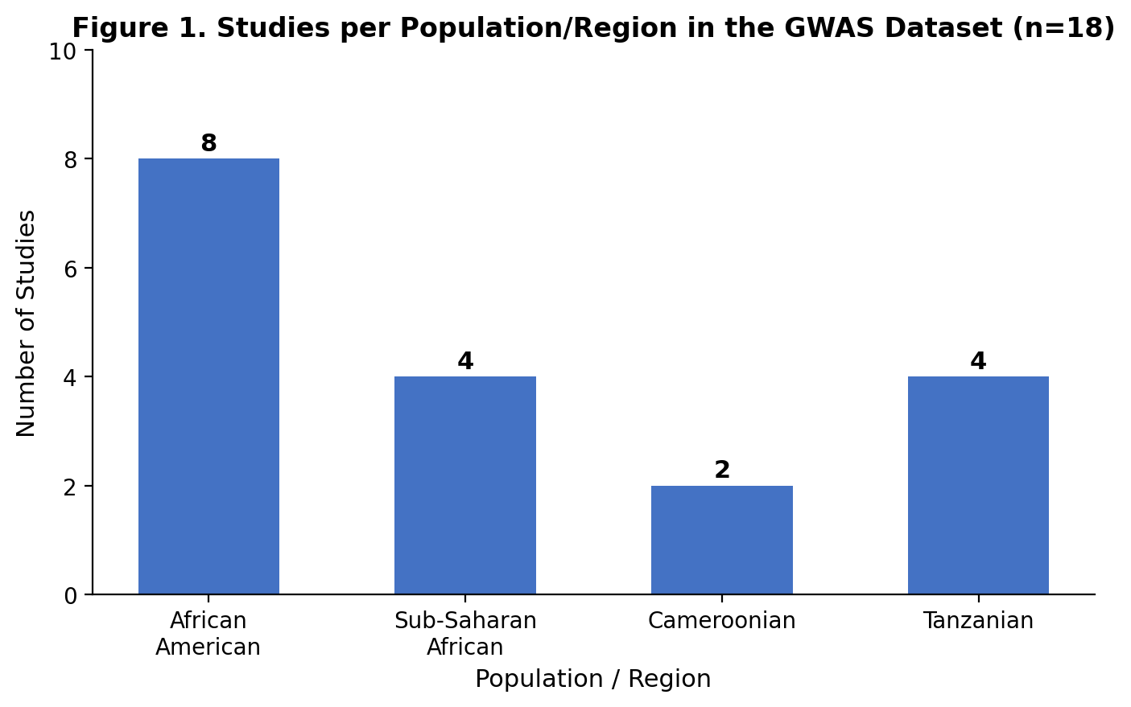
Figure 1. Number of GWAS studies by population/region represented in the dataset (n = 18).
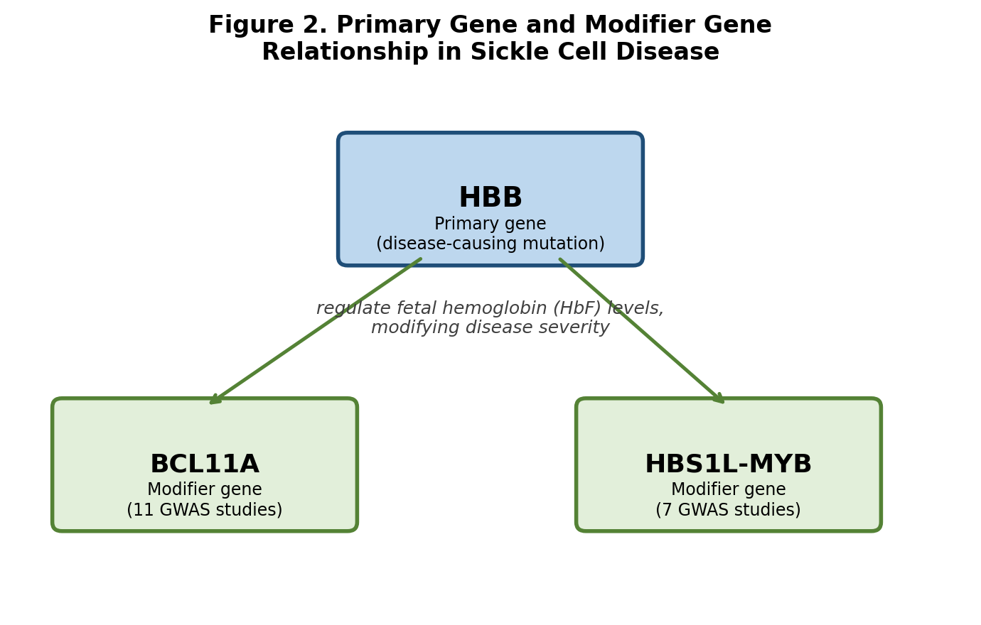
Figure 2. Relationship between the primary gene (HBB) and the two modifier genes (BCL11A, HBS1L-MYB) analyzed in this project.
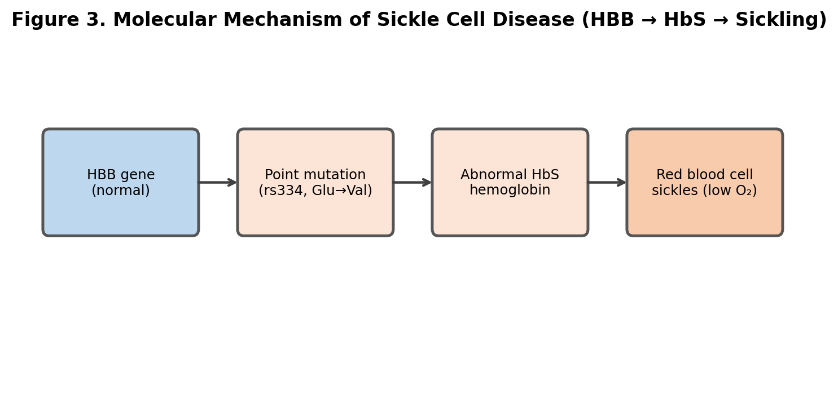
Figure 3. Molecular mechanism by which the HBB point mutation produces sickle-shaped red blood cells.

10. Discussion
This project illustrates a core principle in disease genomics: a single causal mutation rarely tells the whole clinical story. HBB explains why sickle cell disease occurs, but BCL11A and HBS1L-MYB genes uncovered through population-level GWAS studies explain much of the variation in how severely the disease manifests between individual patients. Both modifier genes converge on the same mechanism: regulating residual fetal hemoglobin production into adulthood.
This biology modifier is not purely academic. It is the direct mechanistic basis of the newest sickle cell disease therapies: Casgevy (exa-cel) and the 2026 CRISPR-Cas12a therapy reported in the New England Journal of Medicine both work by editing genes to boost fetal hemoglobin production, achieving outcomes described as a functional cure in the majority of treated patients. This project's focus on BCL11A and HBS1L-MYB is therefore directly relevant to understanding how current gene therapies for sickle cell disease actually work.
The population distribution of the underlying GWAS data also reveals a broader pattern in genomic research: the populations studied are not evenly distributed globally, and findings from well-studied groups such as African Americans and Sub-Saharan Africans do not automatically generalize to under-studied populations such as Pakistan's.

11. Limitations
- This is a secondary-data analysis of publicly available records, not an original genome-wide association study; no new statistical association testing was performed.
- The dataset (18 studies) is a curated subset of GWAS Catalog records for two specific modifier genes, not an exhaustive or systematic review of all sickle cell disease genomics literature.
- No South Asian or Pakistani-specific GWAS data exists in the GWAS Catalog for sickle cell disease modifier genes at the time of this project, so no direct genomic comparison to Pakistani populations could be made; regional relevance is discussed qualitatively rather than quantitatively.
- Allele frequency figures cited for African American and Sub-Saharan African populations are drawn from published literature rather than independently calculated from this project's dataset, and frequency data was not available for the Cameroonian or Tanzanian subgroups specifically.
- As a first genomics project, gene function descriptions and biological explanations were synthesized from reference databases (GeneCards, OMIM, NCBI Gene) rather than derived from primary literature review or laboratory data.

12. Conclusion
This project illustrates a core principle in disease genomics: a single causal mutation does not fully explain a disease's clinical variability, modifier genes, uncovered through population-level GWAS studies, do. It also highlights a broader pattern in genomic research itself: the populations studied are not evenly distributed, and findings from well-studied groups like African Americans and Sub-Saharan Africans don't automatically generalize to under-studied populations such as Pakistan's. Closing this gap matters beyond academic completeness , as gene therapies increasingly rely on modifier-gene biology, understanding how these genes vary across all populations, not just the most-studied ones, will directly shape who current treatments can effectively help.

13. Future Work
- Conduct a dedicated literature search (beyond GWAS Catalog) for any published sickle cell disease prevalence or genetic studies specific to Pakistani populations, including Sindh and Balochistan.
- Expand the modifier gene search to include other reported sickle cell severity modifiers beyond BCL11A and HBS1L-MYB.
- Investigate allele frequency data for rs334 and related modifier variants specifically in South Asian reference populations, where available in databases such as gnomAD.
- Explore how findings from this project could inform future genomic research proposals focused on under-studied South Asian populations.

14. References
1. GWAS Catalog. European Bioinformatics Institute (EBI) / NHGRI-EBI Catalog of human genome-wide association studies. https://www.ebi.ac.uk/gwas/
2. GeneCards , The Human Gene Database. https://www.genecards.org/
3. NCBI Gene. National Center for Biotechnology Information. https://www.ncbi.nlm.nih.gov/gene/
4. OMIM ,Online Mendelian Inheritance in Man. Sickle Cell Anemia, #603903; HBB Gene, #141900. https://omim.org/
5. ClinVar. National Center for Biotechnology Information. https://www.ncbi.nlm.nih.gov/clinvar/
6. dbSNP. rs334 record. National Center for Biotechnology Information. https://www.ncbi.nlm.nih.gov/snp/rs334
7. Wonkam A, et al. (2025). Fetal hemoglobin modifying loci in sickle cell disease across African ancestries. Nature Communications. PMID: 40025045.
8. Rampersaud E, et al. (2021). Fetal hemoglobin QTL mapping in Sickle cell disease cohorts. PMID: 34283174.
9. Mtairo SN, et al. (2014). Genome-wide association study of fetal hemoglobin in Tanzanian sickle cell patients. PMID: 25372704.
10. Griffin PJ, et al. (2014). Genetic variants influencing hemoglobin A2 levels in sickle cell disease. PMID: 25042611.
11. Bhatnagar P, et al. (2011). Genome-wide association study of F-cell distribution in sickle cell disease. PMID: 21326311.
12. Milton JN, et al. (2013). Genetic determinants of haemolysis in sickle cell anaemia. British Journal of Haematology. PMID: 23406172.
13. A gene-edited cell therapy for severe sickle cell disease. New England Journal of Medicine, April 2026 (CRISPR-Cas12a HBG1/HBG2 promoter editing study).

